CHAPTER 10
Cell Cycle and Cell Division
• Cell Cycle and Cell Division

Class 11 - Chapter 10 - NEET replacement notes built from the NCERT chapter text, its 4 figures (8 panels), its summary and its 16 exercises.
Every organism, even the largest, starts its life from a single cell. Growth and reproduction are characteristics of cells, indeed of all living organisms. All cells reproduce by dividing into two, with each parental cell giving rise to two daughter cells each time they divide. These newly formed daughter cells can themselves grow and divide, giving rise to a new cell population formed by the growth and division of a single parental cell and its progeny. Such cycles of growth and division allow a single cell to form a structure consisting of millions of cells.
10.1 | Cell Cycle

According to the cell theory, cells arise from preexisting cells. Any sexually reproducing organism starts its life cycle from a single-celled zygote. Cell division does not stop with the formation of the mature organism but continues throughout its life cycle.
Cell division is a very important process in all living organisms. During the division of a cell, DNA replication and cell growth also take place. All these processes, i.e., cell division, DNA replication, and cell growth, hence, have to take place in a coordinated way to ensure correct division and formation of progeny cells containing intact genomes.
• The cell cycle is the sequence of events by which a cell duplicates its genome, synthesises the other constituents of the cell and eventually divides into two daughter cells.
Although cell growth (in terms of cytoplasmic increase) is a continuous process, DNA synthesis occurs only during one specific stage in the cell cycle. The replicated chromosomes (DNA) are then distributed to daughter nuclei by a complex series of events during cell division. These events are themselves under genetic control.
10.1.1 | Phases of Cell Cycle

A typical eukaryotic cell cycle is illustrated by human cells in culture. These cells divide once in approximately every 24 hours. However, this duration of cell cycle can vary from organism to organism and also from cell type to cell type: yeast, for example, can progress through the cell cycle in only about 90 minutes.
The cell cycle is divided into two basic phases:
• Interphase - the phase between two successive M phases.
• M Phase (Mitosis phase) - the phase when the actual cell division or mitosis occurs.
In the 24 hour average duration of cell cycle of a human cell, cell division proper lasts for only about an hour, while the interphase lasts more than 95% of the duration of cell cycle.
The M Phase starts with the nuclear division, corresponding to the separation of daughter chromosomes (karyokinesis), and usually ends with division of cytoplasm (cytokinesis).
The interphase, though called the resting phase, is the time during which the cell is preparing for division by undergoing both cell growth and DNA replication in an orderly manner. It is divided into three further phases:
Phase of interphase | What defines it | What happens in it
G1 phase (Gap 1) | The interval between mitosis and initiation of DNA replication. | The cell is metabolically active and continuously grows but does not replicate its DNA. It is the period when the cell grows and carries out normal metabolism; most of the organelle duplication also occurs during this phase.
S phase (Synthesis) | The period during which DNA synthesis or replication takes place; it marks DNA replication and chromosome duplication. | The amount of DNA per cell doubles - if the initial amount of DNA is denoted as 2C then it increases to 4C. However, there is no increase in the chromosome number. In animal cells, DNA replication begins in the nucleus and the centriole duplicates in the cytoplasm.
G2 phase (Gap 2) | The period of cytoplasmic growth, between S phase and mitosis. | Proteins are synthesised in preparation for mitosis while cell growth continues.

[NOTE] The S phase doubles the DNA (2C to 4C) but not the chromosome number: if the cell had diploid or 2n number of chromosomes at G1, even after S phase the number of chromosomes remains the same, i.e., 2n. Each chromosome simply now carries two chromatids instead of one.

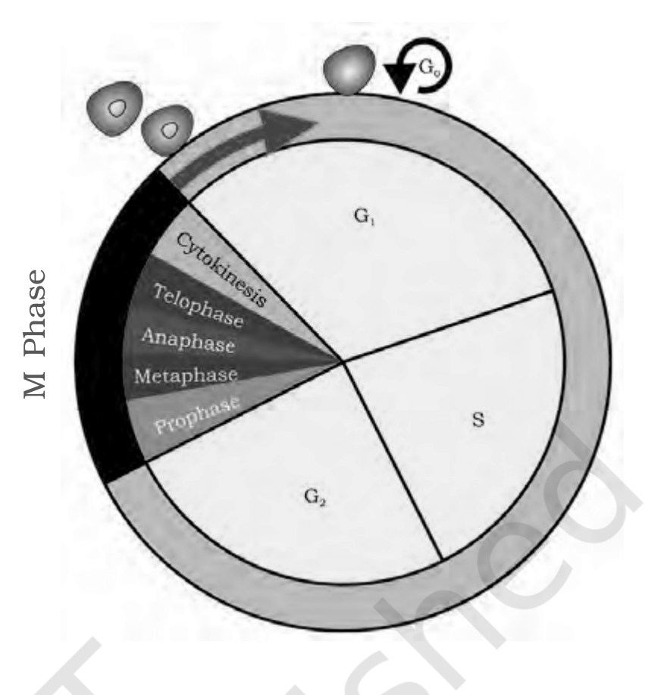
Fig. 10.1 - A diagrammatic view of cell cycle indicating formation of two cells from one cell.
Labels printed in the figure: M Phase; Cytokinesis; Telophase; Anaphase; Metaphase; Prophase; G1; S; G2; G0
The cycle runs continuously, one round feeding the next:
1 | (cycle - last step feeds back to step 1)
2 | G1 - cell grows, metabolises normally, duplicates most organelles; DNA is not yet replicated.
3 | S - DNA replication and chromosome duplication; DNA goes 2C to 4C, chromosome number stays 2n; in animal cells the centriole duplicates.
4 | G2 - cytoplasmic growth continues and proteins are synthesised in preparation for mitosis.
5 | M Phase - karyokinesis through prophase, metaphase, anaphase and telophase, usually followed by cytokinesis, giving two daughter cells.

Chromosome number and DNA content through the cycle (the figures NCERT gives, collected in one place):
Stage | Chromosome number | DNA content
At G1 | 2n (diploid) | 2C
After S phase | 2n - unchanged, no increase in chromosome number | 4C
At G2 | 2n | 4C
After M phase (each daughter cell of mitosis) | 2n - the same as the parent, which is why mitosis is equational division | 2C
At the end of meiosis II (each of the four cells) | n (haploid) - reduced by half | C

[NOTE] Onion root tip cells have 16 chromosomes in each cell. The chromosome number is therefore 16 at G1, 16 after S phase (S doubles DNA, not chromosome number) and 16 after M phase. If the DNA content after M phase is 2C, then it is 2C at G1, 4C after S phase and 4C at G2. NCERT poses exactly this question in the text; the reasoning uses only the S-phase rule above.

Cells that stop dividing. Some cells in the adult animals do not appear to exhibit division (e.g., heart cells). Many other cells divide only occasionally, as needed to replace cells that have been lost because of injury or cell death.
• Cells that do not divide further exit G1 phase to enter an inactive stage called quiescent stage (G0) of the cell cycle. Cells in this stage remain metabolically active but no longer proliferate unless called on to do so depending on the requirement of the organism.
Which cells divide by mitosis. In animals, mitotic cell division is only seen in the diploid somatic cells. However, there are few exceptions to this where haploid cells divide by mitosis, for example, male honey bees. Against this, the plants can show mitotic divisions in both haploid and diploid cells.
[NOTE] NCERT stops the reader three times inside this section to think, and each question is answerable from the chapter itself. (i) How do plants and animals continue to grow all their lives? Do all cells in a plant divide all the time? Do you think all cells continue to divide in all plants and animals? Can you tell the name and the location of tissues having cells that divide all their life in higher plants? Do animals have similar meristematic tissues? - the meristematic tissues, the apical and the lateral cambium, are the plant tissues whose mitotic divisions continue lifelong (10.3), and heart cells and G0 cells show that not all cells keep dividing. (ii) From your recollection of examples of alternation of generations in plants (Chapter 3) identify plant species and stages at which mitosis is seen in haploid cells - the chapter's own answer is that plants can show mitotic divisions in both haploid and diploid cells. (iii) You have studied mitosis in onion root tip cells. It has 16 chromosomes in each cell. Can you tell how many chromosomes will the cell have at G1 phase, after S phase, and after M phase? Also, what will be the DNA content of the cells at G1, after S and at G2, if the content after M phase is 2C? - worked out in the NOTE above.

10.2 | M Phase (Mitosis) - Equational Division

This is the most dramatic period of the cell cycle, involving a major reorganisation of virtually all components of the cell. Since the number of chromosomes in the parent and progeny cells is the same, it is also called as equational division.
Though for convenience mitosis has been divided into four stages of nuclear division (karyokinesis), it is very essential to understand that cell division is a progressive process and very clear-cut lines cannot be drawn between various stages. Karyokinesis involves the following four stages:
1 | Prophase - chromosomal material condenses into compact mitotic chromosomes; the mitotic apparatus is assembled.
2 | Metaphase - all the chromosomes come to lie at the equator on the metaphase plate.
3 | Anaphase - centromeres split and the daughter chromatids move to opposite poles.
4 | Telophase - chromosomes decondense at the poles and two daughter nuclei form.

10.2.1 | Prophase

Prophase, which is the first stage of karyokinesis of mitosis, follows the S and G2 phases of interphase. In the S and G2 phases, the new DNA molecules formed are not distinct but intertwined. Prophase is marked by the initiation of condensation of chromosomal material: the chromosomal material becomes untangled during the process of chromatin condensation. The centrosome, which had undergone duplication during S phase of interphase, now begins to move towards opposite poles of the cell; simultaneously, the centrioles move to the opposite poles.
Key events of prophase:
• Chromosomal material condenses to form compact mitotic chromosomes.
• Chromosomes are seen to be composed of two chromatids attached together at the centromere.
• Centrosome which had undergone duplication during interphase, begins to move towards opposite poles of the cell. Each centrosome radiates out microtubules called asters.
• The two asters together with spindle fibres forms the mitotic apparatus.
• The nuclear envelope and the nucleolus disappear and the spindle fibres start appearing.
Cells at the end of prophase, when viewed under the microscope, do not show golgi complexes, endoplasmic reticulum, nucleolus and the nuclear envelope.
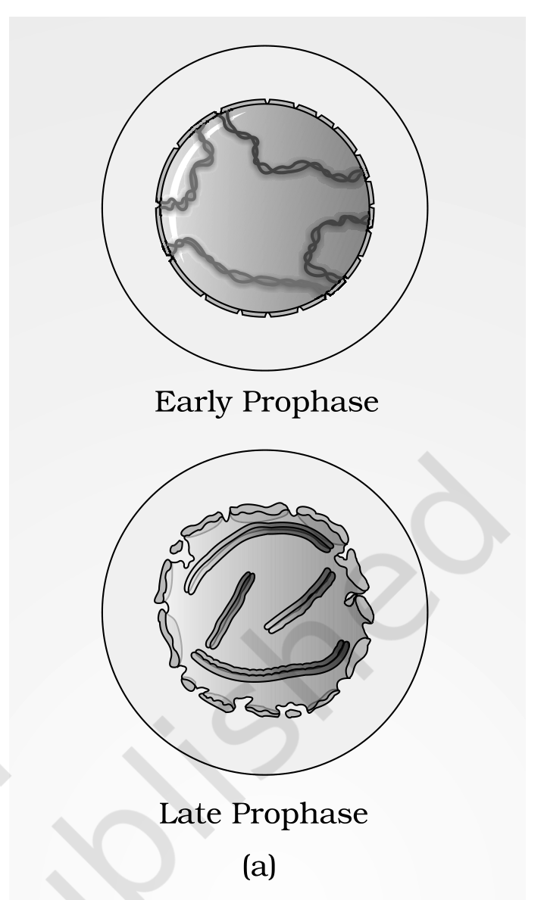
Fig. 10.2 (a) - A diagrammatic view of stages in mitosis: early prophase and late prophase.
Labels printed in the figure: Early Prophase; Late Prophase
10.2.2 | Metaphase

The complete disintegration of the nuclear envelope marks the start of the second phase of mitosis, hence the chromosomes are spread through the cytoplasm of the cell. By this stage, condensation of chromosomes is completed and they can be observed clearly under the microscope. This then, is the stage at which morphology of chromosomes is most easily studied.
At this stage, metaphase chromosome is made up of two sister chromatids, which are held together by the centromere.
• Small disc-shaped structures at the surface of the centromeres are called kinetochores. These structures serve as the sites of attachment of spindle fibres to the chromosomes that are moved into position at the centre of the cell.
The metaphase is characterised by all the chromosomes coming to lie at the equator with one chromatid of each chromosome connected by its kinetochore to spindle fibres from one pole and its sister chromatid connected by its kinetochore to spindle fibres from the opposite pole. The plane of alignment of the chromosomes at metaphase is referred to as the metaphase plate.
Key events of metaphase:
• Spindle fibres attach to kinetochores of chromosomes.
• Chromosomes are moved to spindle equator and get aligned along metaphase plate through spindle fibres to both poles.
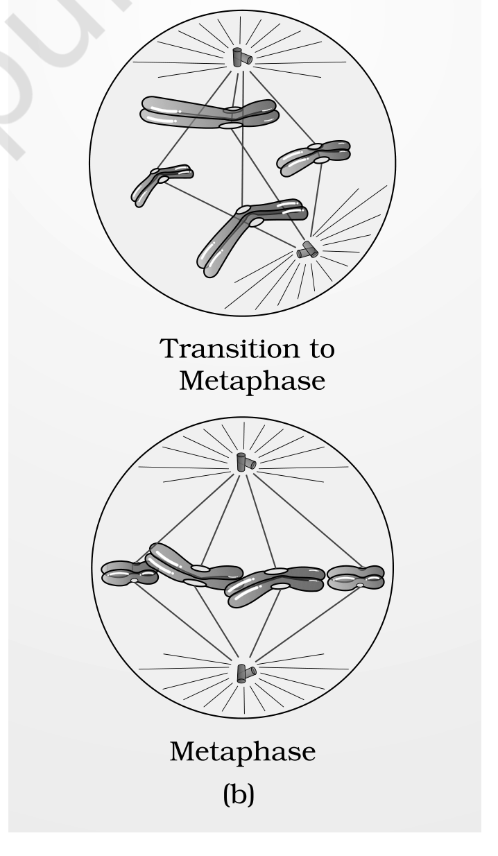
Fig. 10.2 (b) - A diagrammatic view of stages in mitosis: transition to metaphase and metaphase.
Labels printed in the figure: Transition to Metaphase; Metaphase
10.2.3 | Anaphase

At the onset of anaphase, each chromosome arranged at the metaphase plate is split simultaneously and the two daughter chromatids, now referred to as daughter chromosomes of the future daughter nuclei, begin their migration towards the two opposite poles.
As each chromosome moves away from the equatorial plate, the centromere of each chromosome remains directed towards the pole and hence at the leading edge, with the arms of the chromosome trailing behind.
Key events of anaphase:
• Centromeres split and chromatids separate.
• Chromatids move to opposite poles.
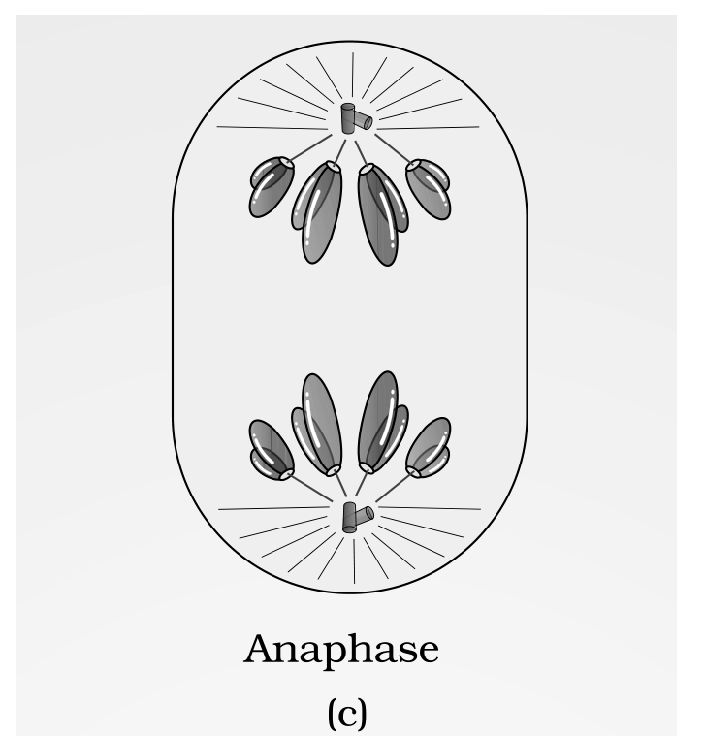
Fig. 10.2 (c) - A diagrammatic view of stages in Mitosis: anaphase.
Labels printed in the figure: Anaphase
10.2.4 | Telophase

At the beginning of the final stage of karyokinesis, i.e., telophase, the chromosomes that have reached their respective poles decondense and lose their individuality. The individual chromosomes can no longer be seen and each set of chromatin material tends to collect at each of the two poles. Once the chromatids reach the two poles, the chromosomal elongation starts, nucleolus and the nuclear membrane reappear.
Key events of telophase:
• Chromosomes cluster at opposite spindle poles and their identity is lost as discrete elements.
• Nuclear envelope develops around the chromosome clusters at each pole forming two daughter nuclei.
• Nucleolus, golgi complex and ER reform.
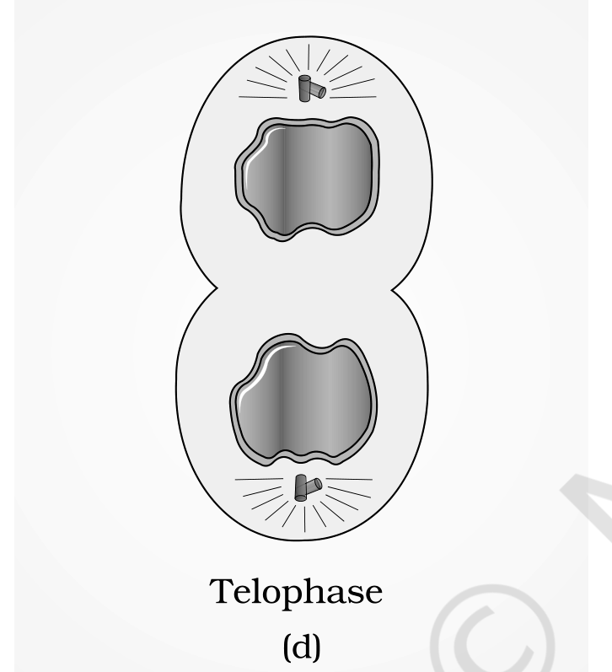
Fig. 10.2 (d) - A diagrammatic view of stages in Mitosis: telophase.
Labels printed in the figure: Telophase
10.2.5 | Cytokinesis

Mitosis accomplishes not only the segregation of duplicated chromosomes into daughter nuclei (karyokinesis), but the cell itself is divided into two daughter cells by the separation of cytoplasm called cytokinesis, at the end of which cell division gets completed.
Cytokinesis in | Mechanism | Why
Animal cell | Achieved by the appearance of a furrow in the plasma membrane. The furrow gradually deepens and ultimately joins in the centre, dividing the cell cytoplasm into two. | The plasma membrane can be pulled inward.
Plant cell | Wall formation starts in the centre of the cell and grows outward to meet the existing lateral walls. The formation of the new cell wall begins with the formation of a simple precursor, called the cell-plate, that represents the middle lamella between the walls of two adjacent cells. | Plant cells however, are enclosed by a relatively inextensible cell wall, therefore they undergo cytokinesis by a different mechanism.

At the time of cytoplasmic division, organelles like mitochondria and plastids get distributed between the two daughter cells.
• In some organisms karyokinesis is not followed by cytokinesis, as a result of which a multinucleate condition arises leading to the formation of syncytium (e.g., liquid endosperm in coconut).
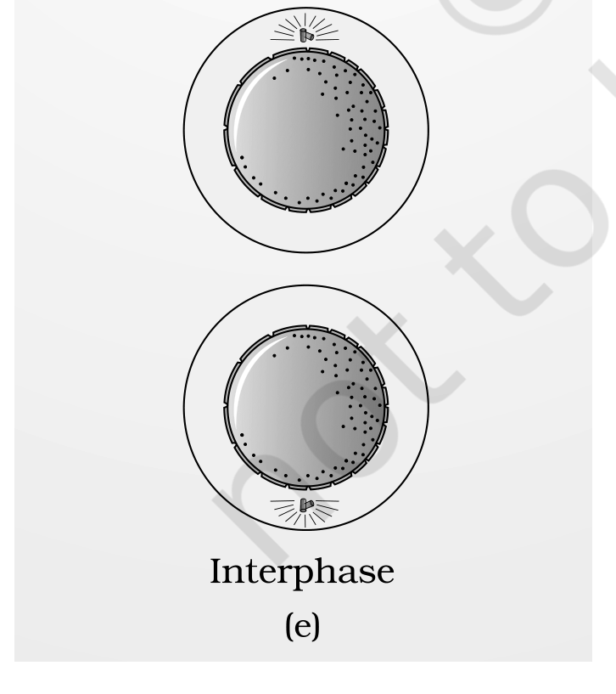
Fig. 10.2 (e) - A diagrammatic view of stages in Mitosis: interphase, the state the daughter cells return to once division is complete.
Labels printed in the figure: Interphase
10.3 | Significance of Mitosis

Mitosis or the equational division is usually restricted to the diploid cells only. However, in some lower plants and in some social insects haploid cells also divide by mitosis. It is very essential to understand the significance of this division in the life of an organism. Mitosis usually results in the production of diploid daughter cells with identical genetic complement.
NCERT asks here: are you aware of some examples where you have studied about haploid and diploid insects? The chapter's own example of a haploid animal cell dividing by mitosis is the male honey bee (10.1.1).
• Growth. The growth of multicellular organisms is due to mitosis.
• Restoring the nucleo-cytoplasmic ratio. Cell growth results in disturbing the ratio between the nucleus and the cytoplasm. It therefore becomes essential for the cell to divide to restore the nucleo-cytoplasmic ratio.
• Cell repair. A very significant contribution of mitosis is cell repair. The cells of the upper layer of the epidermis, cells of the lining of the gut, and blood cells are being constantly replaced.
• Continuous growth in plants. Mitotic divisions in the meristematic tissues - the apical and the lateral cambium - result in a continuous growth of plants throughout their life.
10.4 | Meiosis - Reduction Division

The production of offspring by sexual reproduction includes the fusion of two gametes, each with a complete haploid set of chromosomes. Gametes are formed from specialised diploid cells.
• Meiosis is the specialised kind of cell division that reduces the chromosome number by half and results in the production of haploid daughter cells. It is called the reduction division since it reduces the chromosome number by half while making the gametes.
Meiosis ensures the production of the haploid phase in the life cycle of sexually reproducing organisms, whereas fertilisation restores the diploid phase. We come across meiosis during gametogenesis in plants and animals; this leads to the formation of haploid gametes.
Key features of meiosis:
• Meiosis involves two sequential cycles of nuclear and cell division called meiosis I and meiosis II but only a single cycle of DNA replication.
• Meiosis I is initiated after the parental chromosomes have replicated to produce identical sister chromatids at the S phase.
• Meiosis involves pairing of homologous chromosomes and recombination between non-sister chromatids of homologous chromosomes.
• Four haploid cells are formed at the end of meiosis II.
Meiotic events can be grouped under the following phases:
Division | Phases, in order
Meiosis I | Prophase I - Metaphase I - Anaphase I - Telophase I
Meiosis II | Prophase II - Metaphase II - Anaphase II - Telophase II

Mitosis compared with meiosis (every fact below is stated in 10.2-10.4; nothing new is added here):
Feature | Mitosis | Meiosis
Also called | Equational division | Reduction division
Cells in which it occurs | Usually restricted to the diploid cells only; in some lower plants and some social insects haploid cells also divide by mitosis; in animals only in diploid somatic cells, except male honey bees | Diploid cells destined to form gametes; met during gametogenesis in plants and animals
Nuclear/cell division cycles | One | Two sequential cycles - meiosis I and meiosis II
Cycles of DNA replication | One | Only a single cycle, before meiosis I
Pairing of homologous chromosomes | Does not occur | Occurs (synapsis), forming bivalents
Crossing over / recombination | Does not occur | Occurs between non-sister chromatids of homologous chromosomes
What separates at anaphase | Centromeres split and sister chromatids separate | Anaphase I: homologous chromosomes separate while sister chromatids remain associated at their centromeres. Anaphase II: centromeres split and sister chromatids separate
Products | Usually diploid daughter cells with identical genetic complement | Four haploid cells (a tetrad of cells)
Chromosome number in products | Same as the parent (2n from 2n) | Half that of the parent (n from 2n)

10.4.1 | Meiosis I

Prophase of the first meiotic division is typically longer and more complex when compared to prophase of mitosis. It has been further subdivided into the following five phases based on chromosomal behaviour, i.e., Leptotene, Zygotene, Pachytene, Diplotene and Diakinesis.
1 | Leptotene - the chromosomes become gradually visible under the light microscope. The compaction of chromosomes continues throughout leptotene.
2 | Zygotene - chromosomes start pairing together and this process of association is called synapsis. Such paired chromosomes are called homologous chromosomes. Electron micrographs of this stage indicate that chromosome synapsis is accompanied by the formation of a complex structure called the synaptonemal complex. The complex formed by a pair of synapsed homologous chromosomes is called a bivalent or a tetrad; however, these are more clearly visible at the next stage.
3 | Pachytene - the first two stages of prophase I are relatively short-lived compared to this stage. The four chromatids of each bivalent chromosome become distinct and clearly appear as tetrads. This stage is characterised by the appearance of recombination nodules, the sites at which crossing over occurs between non-sister chromatids of the homologous chromosomes. Recombination between homologous chromosomes is completed by the end of pachytene, leaving the chromosomes linked at the sites of crossing over.
4 | Diplotene - recognised by the dissolution of the synaptonemal complex and the tendency of the recombined homologous chromosomes of the bivalents to separate from each other except at the sites of crossovers. These X-shaped structures are called chiasmata. In oocytes of some vertebrates, diplotene can last for months or years.
5 | Diakinesis - the final stage of meiotic prophase I, marked by terminalisation of chiasmata. During this phase the chromosomes are fully condensed and the meiotic spindle is assembled to prepare the homologous chromosomes for separation. By the end of diakinesis, the nucleolus disappears and the nuclear envelope also breaks down. Diakinesis represents transition to metaphase.

• Crossing over is the exchange of genetic material between two homologous chromosomes. It is also an enzyme-mediated process and the enzyme involved is called recombinase. Crossing over leads to recombination of genetic material on the two chromosomes.
Metaphase I. The bivalent chromosomes align on the equatorial plate. The microtubules from the opposite poles of the spindle attach to the kinetochore of homologous chromosomes.
Anaphase I. The homologous chromosomes separate, while sister chromatids remain associated at their centromeres. Homologous chromosomes move to the opposite poles with both their chromatids, so each pole receives half the chromosome number of the parent cell.
Telophase I. The nuclear membrane and nucleolus reappear, cytokinesis follows and this is called as dyad of cells. Although in many cases the chromosomes do undergo some dispersion, they do not reach the extremely extended state of the interphase nucleus.
• The stage between the two meiotic divisions is called interkinesis and is generally short lived. There is no replication of DNA during interkinesis. Interkinesis is followed by prophase II, a much simpler prophase than prophase I.
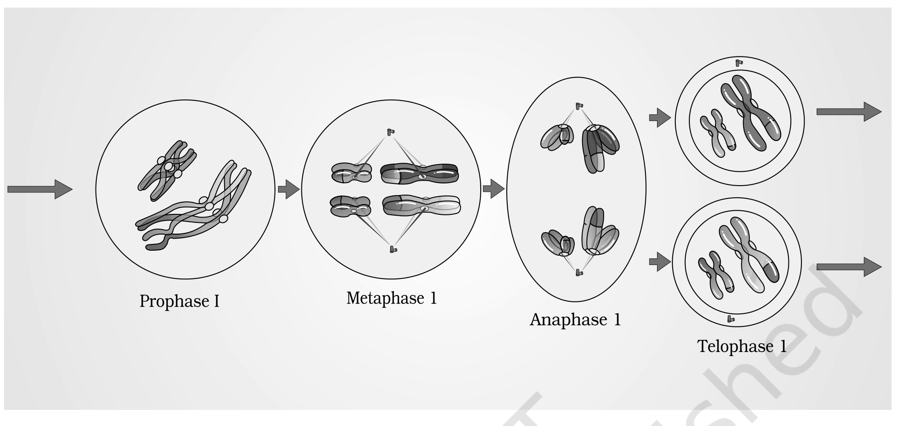
Fig. 10.3 - Stages of Meiosis I.
Labels printed in the figure: Prophase I; Metaphase 1; Anaphase 1; Telophase 1
10.4.2 | Meiosis II

Prophase II. Meiosis II is initiated immediately after cytokinesis, usually before the chromosomes have fully elongated. In contrast to meiosis I, meiosis II resembles a normal mitosis. The nuclear membrane disappears by the end of prophase II and the chromosomes again become compact.
Metaphase II. At this stage, the chromosomes align at the equator and the microtubules from opposite poles of the spindle get attached to the kinetochores of sister chromatids.
Anaphase II. It begins with the simultaneous splitting of the centromere of each chromosome (which was holding the sister chromatids together), allowing them to move toward opposite poles of the cell by shortening of microtubules attached to kinetochores.
Telophase II. Meiosis ends with telophase II, in which the two groups of chromosomes once again get enclosed by a nuclear envelope; cytokinesis follows, resulting in the formation of a tetrad of cells, i.e., four haploid daughter cells.
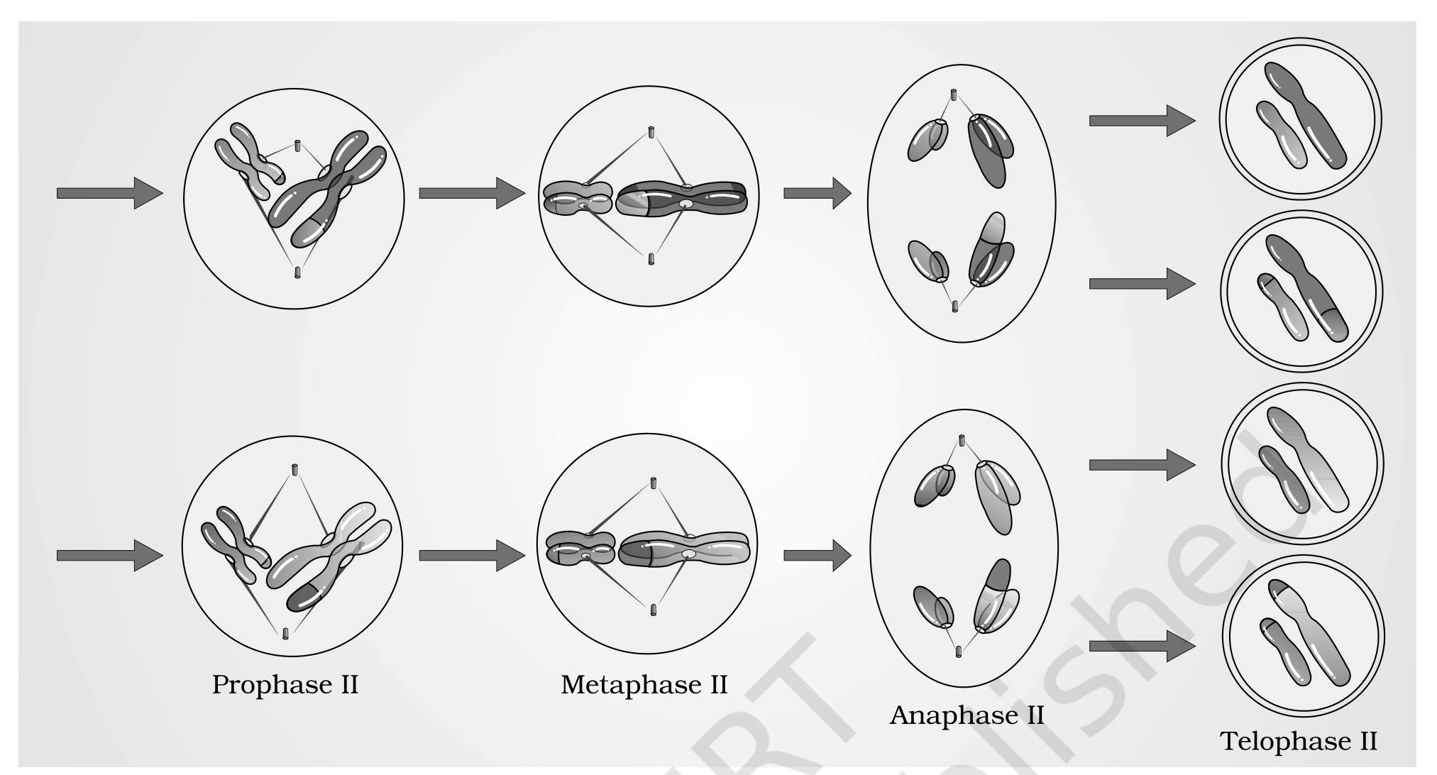
Fig. 10.4 - Stages of Meiosis II.
Labels printed in the figure: Prophase II; Metaphase II; Anaphase II; Telophase II
[MEMORY AID - not in NCERT] Prophase I substages in order - Leptotene, Zygotene, Pachytene, Diplotene, Diakinesis: read them as "LZ PDD". The two D stages are the late ones, and the pairing (Z for zygotene, Z for zip-up) comes before the crossing over (P for pachytene).

10.5 | Significance of Meiosis

Meiosis is the mechanism by which conservation of specific chromosome number of each species is achieved across generations in sexually reproducing organisms, even though the process, per se, paradoxically, results in reduction of chromosome number by half.
It also increases the genetic variability in the population of organisms from one generation to the next. Variations are very important for the process of evolution.
QR | Quick Recap

Cells arise from preexisting cells (cell theory); a sexually reproducing organism starts its life cycle from a single-celled zygote, and cell division does not stop with the mature organism but continues throughout its life cycle. The stages through which a cell passes from one division to the next is the cell cycle.
• Two phases: interphase - a period of preparation for cell division; and mitosis (M phase) - the actual period of cell division. Interphase is subdivided into G1, S and G2. G1: cell grows and carries out normal metabolism, most organelle duplication too. S: DNA replication and chromosome duplication (2C to 4C, chromosome number unchanged). G2: cytoplasmic growth, proteins for mitosis. Human cells in culture divide once in about 24 hours, of which division proper is only about an hour and interphase is more than 95%; yeast takes only about 90 minutes. Non-dividing cells rest in G0.
• Mitosis has four stages. Prophase: chromosome condensation, centrioles move to opposite poles, nuclear envelope and nucleolus disappear and spindle fibres start appearing. Metaphase: alignment of chromosomes at the equatorial plate (metaphase plate), kinetochores attached to spindle fibres. Anaphase: centromeres divide and the chromatids start moving towards the two opposite poles. Telophase: once the chromatids reach the two poles the chromosomal elongation starts, nucleolus and nuclear membrane reappear. Nuclear division is then followed by cytoplasmic division, cytokinesis - a furrow in animal cells, a cell-plate growing centre-outward in plant cells. Mitosis thus is the equational division in which the chromosome number of the parent is conserved in the daughter cell; it drives growth, restores the nucleo-cytoplasmic ratio and repairs tissue.
• Meiosis, in contrast, occurs in the diploid cells which are destined to form gametes. It is the reduction division: it halves the chromosome number while making the gametes, and fertilisation restores the parental value. Meiosis I has a long prophase of five substages - leptotene, zygotene, pachytene, diplotene, diakinesis - in which homologous chromosomes pair to form bivalents and undergo crossing over. Metaphase I: bivalents on the equatorial plate. Anaphase I: homologous chromosomes move to opposite poles with both their chromatids, so each pole receives half the parental chromosome number. Telophase I: nuclear membrane and nucleolus reappear. Meiosis II is similar to mitosis, and during anaphase II the sister chromatids separate. Thus at the end of meiosis four haploid cells are formed. Meiosis conserves each species' chromosome number across generations and increases genetic variability, which matters for evolution.
EX | Terms Used in the Exercises

These are the points the end-of-chapter questions lean on that the chapter body states in a scattered way, or does not state at all. Nothing here is imported from outside this chapter; where the chapter genuinely does not supply an answer, that is said plainly.
• "Average cell cycle span for a mammalian cell" (Q1). The chapter never uses the word mammalian: it gives the figure for human cells in culture, which divide once in approximately every 24 hours, of which cell division proper lasts for only about an hour. That 24-hour figure is the average the question asks for.
• Four daughter cells equal or unequal in size (Q9). The chapter states that meiosis is met during gametogenesis in plants and animals and that cytokinesis after telophase II gives a tetrad of cells, i.e., four haploid daughter cells. It does not state their relative sizes anywhere, so the equal-versus-unequal comparison is beyond what this chapter supplies; answer it from the gametogenesis chapters rather than from here.
• Haploid cells in higher plants where cell division does not occur (Q13 ii). The chapter supplies the two halves of this discussion separately: cells that do not divide further exit G1 into the quiescent stage (G0), where they remain metabolically active but no longer proliferate unless called on to do so; and plants can show mitotic divisions in both haploid and diploid cells, with the haploid dividing stages to be identified from alternation of generations (Chapter 3). Haploid plant cells that are not dividing are therefore G0-type cells of the haploid generation; the chapter names no specific example.
• "Can there be mitosis without DNA replication in the S phase?" (Q14). No, as the chapter states the sequence: DNA synthesis occurs only during one specific stage of the cell cycle, the S phase, which marks DNA replication and chromosome duplication; and prophase, the first stage of karyokinesis of mitosis, follows the S and G2 phases of interphase. Mitosis distributes replicated chromosomes, so the replication must have happened first.
• "Can there be DNA replication without cell division?" (Q15). Yes. In some organisms karyokinesis is not followed by cytokinesis, giving a multinucleate condition and the formation of a syncytium, e.g., liquid endosperm in coconut. Note also that no DNA replication takes place during interkinesis, the stage between the two meiotic divisions.
• Chromosome number (N) and DNA content (C) at every stage (Q16), and the mitosis-versus-meiosis differences (Q11). Both are answered by the two tables in the body: the DNA-content table in 10.1.1 and the comparison table in 10.4. Neither adds a fact beyond 10.1.1-10.4.

